**Sequence diagram:**

A sequence diagram shows the interaction of the actor with the objects in the system and the timing of the interactions. It gives a dynamic view by time-sequencing the flow of messages among objects

A sequence diagram is a two-dimensional chart that displays the interaction between actors and the system across the horizontal direction and the sequencing, or timing, of that interaction in the vertical direction.

Better understanding of the various possible interactions that may occur between the actors and the system during the execution of a use case, is through constructing scenario.

A scenario is a description of a sequence of actions that illustrates the execution of a use case instance. In most use cases, several possible scenarios may occur.

One way to document a scenario is to write a text file description of what will happen under a given scenario.

• The text description should document all the steps that the actors will perform and the associated system responses.

• Once a typical scenario is documented, it is straightforward to convert it to a sequence diagram

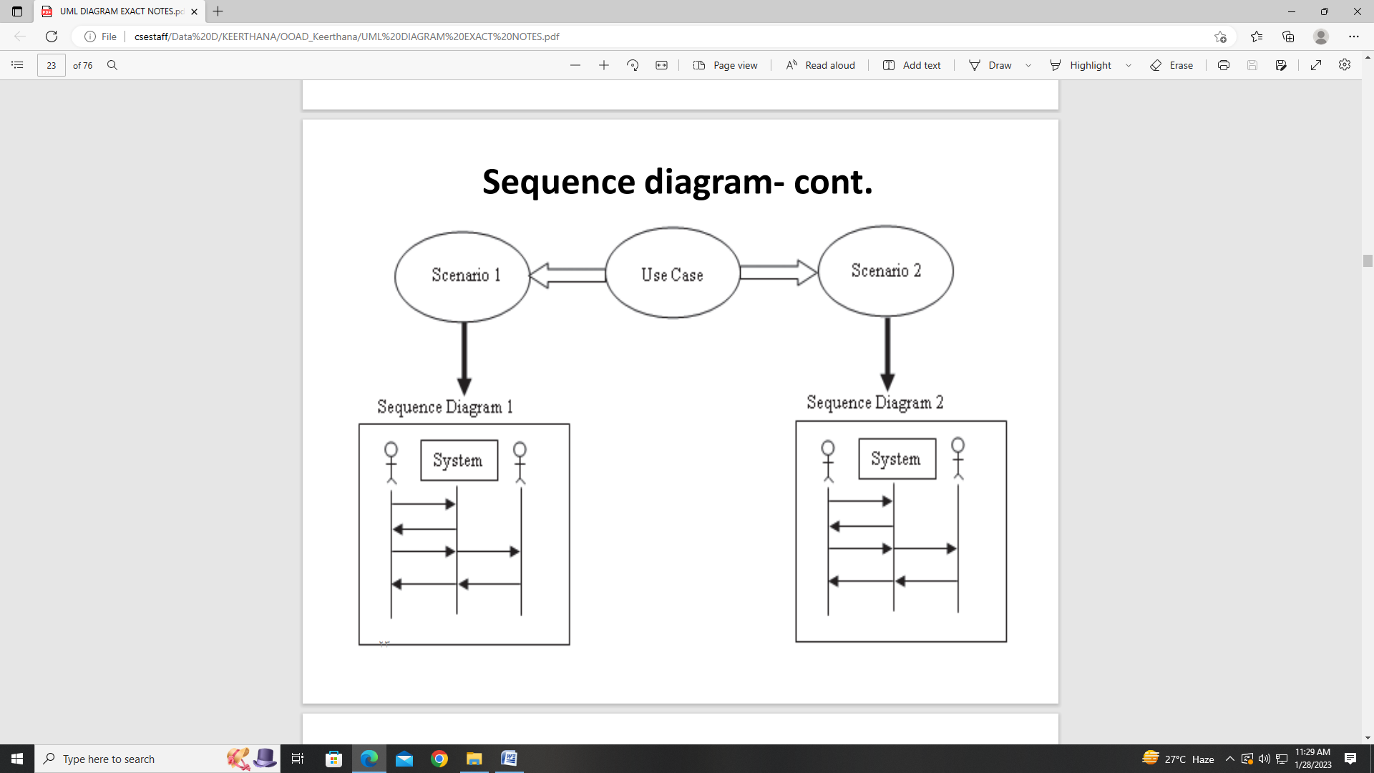

**Sequence diagram: scenario of a use case Scenario**

1: Make Sale Use Case Normal Scenario 1. The customer requests a performance and seating preference from the ticket sale system.

2. The system verifies whether the performance and seating are available.

3. The performance and seating are available. The system offers the ticket to the customer

4. The customer accepts the ticket

5. The system temporarily places the seating for that performance “on hold” while it processes the sale.

6. The system requests credit card information from the customer.

7. The customer supplies credit card information

8. The system requests authorization to debit the credit card from the MasterCard authorization service (we will assume that MasterCard is the only acceptable form of payment)

9. The system receives the authorization approval.

10. The system confirms the sale to the customer and requests final acceptance of the transaction by the customer.

11. The customer accepts the transaction.

12. The system bills the price of the ticket(s) to MasterCard. 13. MasterCard accepts the charge.

14. The system changes the status of the ticket from “on hold” to “sold.

15. The system sends a final confirmation to the customer, which includes the sale transaction number that the customer will use to pick up the ticket at the box office prior to the performance (we don’t mail tickets).

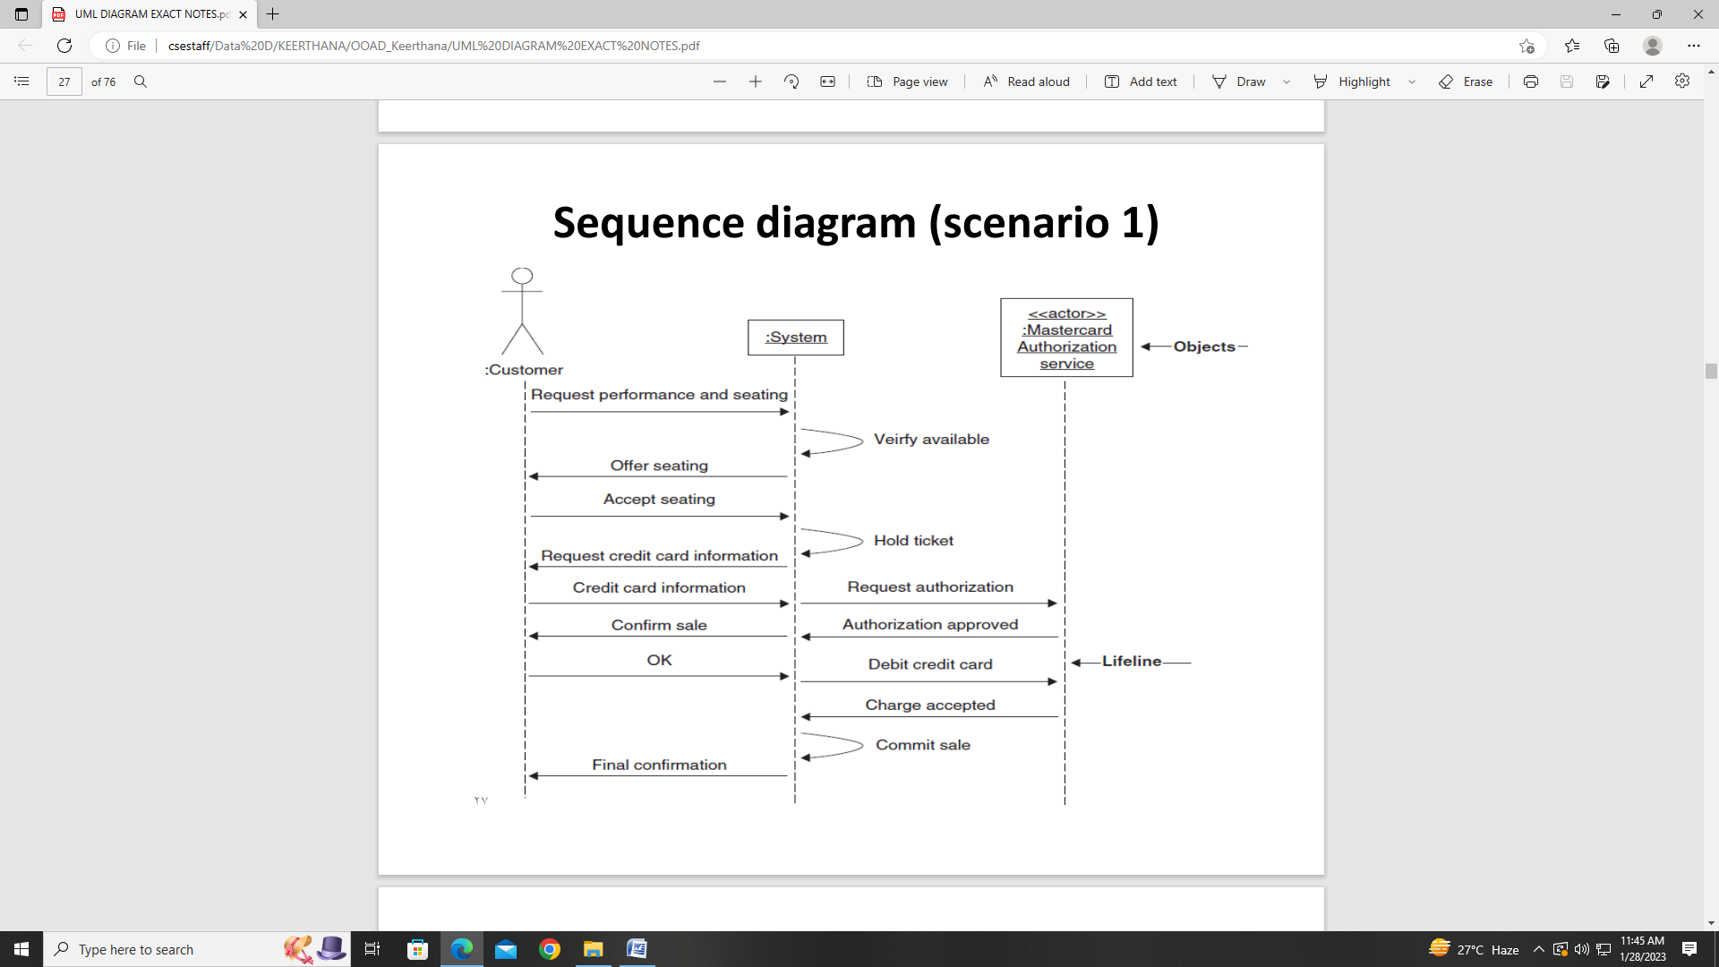

The objects are arranged across the top of the diagram. In this case, they include the customer, system, and MasterCard authorization service.

• The vertical dashed lines beneath the objects are called lifelines.

• The lifeline shows the duration, or persistence, of the object during the scenario. The arcs with arrows indicate the direction of flow of the communication between objects.

